C**ourse:** Principles of Programming Languages **Course ID:** IT092IU

**INTERNATIONAL UNIVERSITY - VIETNAM NATIONAL UNIVERSITY**

**SCHOOL OF COMPUTER SCIENCE AND ENGINEERING**

# **PPL Lab 2**

# **Parser Exercise**

| **NAME** | **STUDENT ID** |
| --- | --- |
| Vũ Nhật Duy | ITITIU17047 |

**Write lexer rules in “BKIT.g4” that can accept the following tokens.**

Example 1:

Program accepts expressions that are integers or identifiers.

Example 2:

* a + b
* Calculating must be performed from left to right.

Exercise 1:

* a + b
* a – b
* Calculating must be performed from left to right.

Exercise 2:

* a + b
* a – b
* a * b
* a / b
* Operator ‘*’ and ‘/’ have higher priority than ‘+’ and ‘-‘.
* Calculating must be performed from left to right in case operators have the same priority.

**Solution:**

**Exercise 1:**

With the provided Parser Code files, changing the program part to meet the requirements in Exercise1.g4

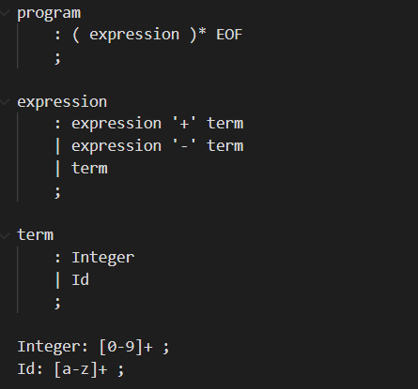

program

: ( expression )* EOF

;

expression

: expression '+' term

| expression '-' term

| term

;

term

: Integer

| Id

;

This ensures + and - are left-associative so that the calculation is performed left to right.

Then after completing, running the code to compile and test with the testcase1.txt

35 + 47

7 + 9 + a

13 - 2

11 - 2 - 2





**Exercise 2:**

With the provided Lexer Code files, changing the program part to meet the requirements in Exercise2.g4

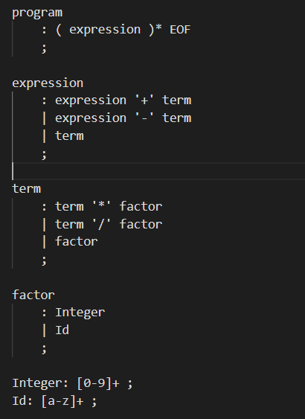

program

: ( expression )* EOF

;

expression

: expression '+' term

| expression '-' term

| term

;

term

: term '*' factor

| term '/' factor

| factor

;

factor

: Integer

| Id

;

Because * and / have higher priority, the rules for term involving * and / appear before the rules for expression involving + and -.

All operators are left-associative, ensuring calculation to be performed from left to right in case operators have the same priority.

Then after completing, running the code to compile and test with the testcase2.txt

35 + 47

7 + 9 + a

13 - 2

11 - 2 - 2

a * b

a * b / c + d - e



